

**Quotation for Landing Page Development**

GST - 06AAICV7138B1ZE https://www.veloxn.com/

**Introduction –**

Thank You for showing interest in Landing Page Development with Veloxn Private Limited.

**Service Cost -**

The table below details the cost associated with this service.

|  |  |  |  |  |
| --- | --- | --- | --- | --- |
| **Name** | **Price** | **Qty.** | **Duration** | **Subtotal** |
| Landing Page Development | ₹2,000 | 1 | - | ₹2,000 |
|  |  |  |  |  |
| **SUB TOTAL** |  |  |  | ₹2,000 |
| GST @ 18% |  |  |  | ₹360 |
| **TOTAL Including GST** |  |  |  | **₹2,360** |

Payment required is **₹2,360** (Offer Valid for 1 Days)

**Bank Details**:

**VELOXN PRIVATE LIMITED**

AC Number – 259958439076

IFSC Code – INDB0000702

Bank Name – Indusind Bank

UPI ID - veloxnservices@okicici

QR Code – 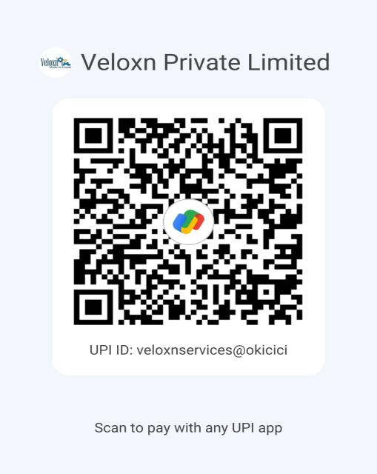

**COMPANY:**

Veloxn Private Limited

Iconic Tower C, Corenthum, Sector-62, Noida, UP - 201301, India www.veloxn.com

sales@veloxn.com

91-7292001010

GST - 06AAICV7138B1ZE